Name
Institutional Affiliation
Date

- Islamic banking literature review
Previous studies acted as an indicator to determine customers’ perception towards Islamic banking. For instance, Hassan (2007) studied customers’ perception towards Islamic banking in Pakistan. His study examined several important dimensions including knowledge, socio-religious context, Shariah compliances, and willingness to deal with Islamic banks, and quality and attractiveness of offerings. This study found a positive perception of all dimensions investigated with customers indicating overall high satisfaction towards products and services of Islamic banks as compared to conventional banks. Rashid, Hassan and Ahmad (2010) conducted a study on perception of customers towards domestic Islamic banks in Bangladesh. They examined six critical elements, namely corporate efficiency, compliance with Islamic rules, convenience, core banking, confidence, and cost benefit. This study found that customers are highly satisfied with corporate efficiency and compliance with Islamic rules as substantial factors for them to choose their intended service. In the case of Malaysia, Dusukiand Abdullah (2006) studied several critical reasons why Malaysian customers patronize Islamic banks and measured the elements of reputation, service delivery, product price, and social responsibility of Islamic banks. The study found that a combination of Islamic and financial reputation and service quality are the main patronage factors.
B.Introduction
Banks are critical when it comes to the economy of any country. The global financial system is a kind of financial system comprising of regulators and institutions that function on global level, rather than regional level. Islamic bank is a typical type of this category. The banks has emerged to be one of the competitive and likely alternatives for the conventional banking during the last few decades. Islamic banking is no longer restricted to one geographical location as well as specialized institutions. It has also expanded in terms of products diversification, with well-organized credit finance which raises eyebrows. This system of banks are governed by the Islamic rules which are also applied in all Islamic economics. The philosophies that focuses on ethical and moral values when it comes to its all dealings
C.History of Islamic banking system
Islamic banking can be traced to the 1960s when it started becoming a common term but the concepts and mechanisms related to this systems were applied and employed since the beginning of Islam. Numerous researches and studies have shown that Islamic finance mechanisms were employed in the Muslim world all through the middle ages; when carrying out business and business activities. Charging interests were not there even during those eras.
.
D.Central banks structure and challenges of Islamic banking system for Afghanistan, Saudi Arabia, Mauritius, Yemen
Central banks have varying structures as well as challenges, even though most of them share the same. A few year ago, Islamic banks were behind when compared to other conventional counterparts when it comes to technology, innovation, and services in general, which are not only significant in defending market francizes but are vital as a differentiating factor when it comes to market competition. Islamic banking continues to extend its coverage and can now compete with other banks. This is supported by an increase in range of products and services. However, there are problems which this banks still face. Most of Islamic banks operate on leasing form of investment and hire purchase i.e. this banks prefer to operate on markup or definite profit basis that are covered by Islamic rules. Due to this, the conventional economists and common people at times fails to comprehend the actual differences between conventional banking and Islamic banking. This is one of the major problem facing Islamic banking as a whole. In addition to that, Musharaka and Mudaraba methods of venture are perfect but Islamic banks haven’t go to this methods.
Islamic banks faces different challenges in different nations. Islamic banking was launched in Afghanistan in 2008 and 2008. The bank started well, with support from conventional banks but this banking system is underdeveloped till present. This is because the country lacks Islamic law and regulations. Additionally, Islamic banking in Afghanistan is faced by numerous challenges such as lack of regulatory and regulation framework, lack of awareness regarding the banking, insufficient investment capital, lack of information and human capacity, lack of Shariah agreement among scholars and Ulema, and lack of shariah acquiescent technology methods. Islamic banks faces almost similar problems since Islamic banks in Yemen, Mauritius and Saudi Arabia faces same challenges. In Yemen, there is poor infrastructure, widespread illiteracy or lack of information, as well as lack of consensus from economic scholars regarding what produces a product shariah-compliant.
.Islamic banking principles
Not like other normal banks which deals primarily with customer relationships and civil contracts, Islamic banking which similarly deals with trusts has its own concepts as well as principles. There is plentiful of literature concerning Islamic banking. The banking system is grounded on one crucial concept: the notion of profit and loss sharing instead of payment of interests. This is the essence and the most dominant principle employed in Islamic banking and other Islamic economics.
Organization charts from each country
Saudi Arabia organizational chart
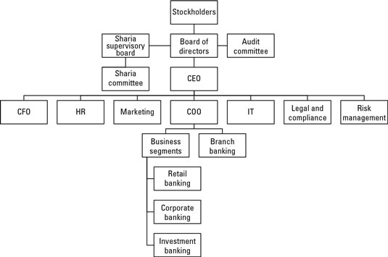

Yemen organizational chart
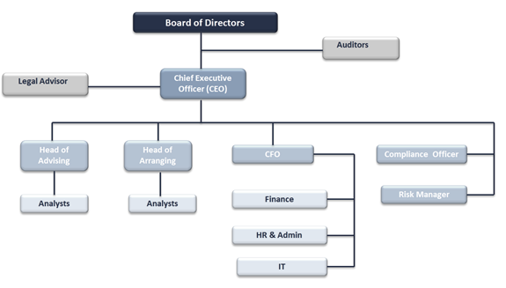
Afghanistan organizational chart
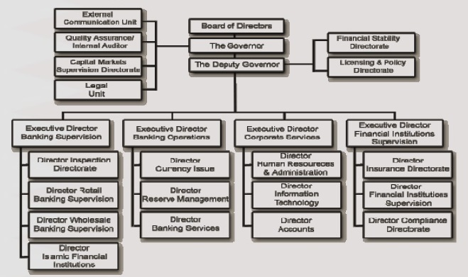
Islamic bank of Mauritius organizational chart
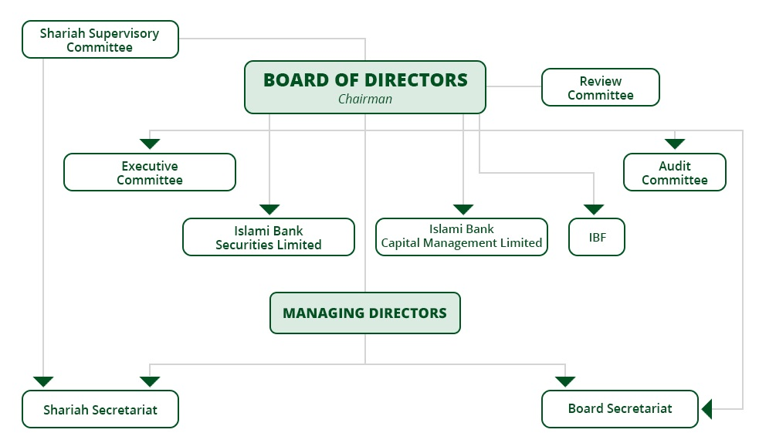

E .Summary
Islamic banking systems in these countries have a common thing. All of them have shariah supervisory committee whose main roles are to ensure the shariah rules and regulations are adhered to. This includes the principles of the Islamic bank such as sharing of profits as well as loses and the notion of lending out loans without interest rates. Like the conventional banks, the Islamic banks have board of directors who oversees all operations taking place in the bank. Additionally, the board of directors rules the bank by shaping policies and procedures. The organizational chat of countries like Afghanistan are structured when compared to that of countries such as Mauritius. This can be attributed to the year the banks was started, and other regional factors.
F.Retail services provided by Islamic banks
All Islamic banks are trade focused organizations which provides deposits without interests as well as investment opportunities for customers. Islamic banks from these four countries accepts deposits from its customers under specific and general investment funds that is openly pointed out in the contract between the customer and the bank at the account opening. The banks deals with various categories of consumers when it comes to their retail services. This comprises borrowers, depositors, as well as service users. The banks carries out numerous operations to offer a range of products as per the customer requirements. It offers funds transfers, credit facilities, and products financing.
G.Ratio analysis
Kader & Asarpota (2007) applied financial ratio analysis to assess the performance of the Saudi Arabian Islamic bank and Afghanistan Islamic banks respectively. Similarly, to measure efficiency of Islamic banks in Yemen (Sarkar 1999) utilized banking efficiency model and claimed that Islamic banks can stay alive even within a traditional banking architecture in which Profit-and-Loss Sharing (PLS) modes of financing are less dominated. Sarkar (1999) further claimed that Islamic financial products have different risk characteristics and consequently different prudential regulations should be in place. Studies which used financial ratio analysis have generally found, contrary to the earlier hypotheses, that Islamic banks are more efficient than conventional banks in terms of resource use, cost effectiveness, profitability, asset quality, capital adequacy and liquidity ratios than conventional banks (Iqbal 2001, Hassan and Bashir 2005). Commercial banks, however, have a more favorable operations ratio. (Hassan and Bashir 2005).
H.Objective of the Bank
- Maximization of the financial profits
- To be one of the leading premer in knowledge of the Islamic banks
Data analysis
Data can be interpreted in a number of ways. Common techniques of analyzing data comprises common size analysis, ratio analysis, trend analysis, cross-sectional analysis as well as regression analysis.
Composition of an Islamic bank’s assets in a 2009

From the above figures, the Islamic bank is growing in terms of assets. The specific assets are dominating rather than general. Things like financing are becoming improved in this banking system.

References
Chong, B. S., & Liu, M. H. (2009). Islamic banking: interest-free or interest-based?. Pacific-Basin Finance Journal, 17(1), 125-144.
Gheeraert, L., & Weill, L. (2015). Does Islamic banking development favor macroeconomic efficiency? Evidence on the Islamic finance-growth nexus. Economic modelling, 47, 32-39.
Sairally, S. (2007). Community development financial institutions: Lessons in social banking for the Islamic financial industry. Kyoto Bulletin of Islamic Area Studies, 1(2), 19-37.

